**Exercise 1: Online Bookstore - Setting Up RESTful Services**

**Business Scenario:**

You are tasked with developing a RESTful service for an online bookstore. The service will manage books, authors, and customers.

**Instructions:**

1. **Setup Spring Boot Project:**
   * Initialize a new Spring Boot project named **BookstoreAPI**.
   * Add dependencies: **Spring Web, Spring Boot DevTools, Lombok**.
2. **Project Structure:**
   * Familiarize yourself with the generated project structure.

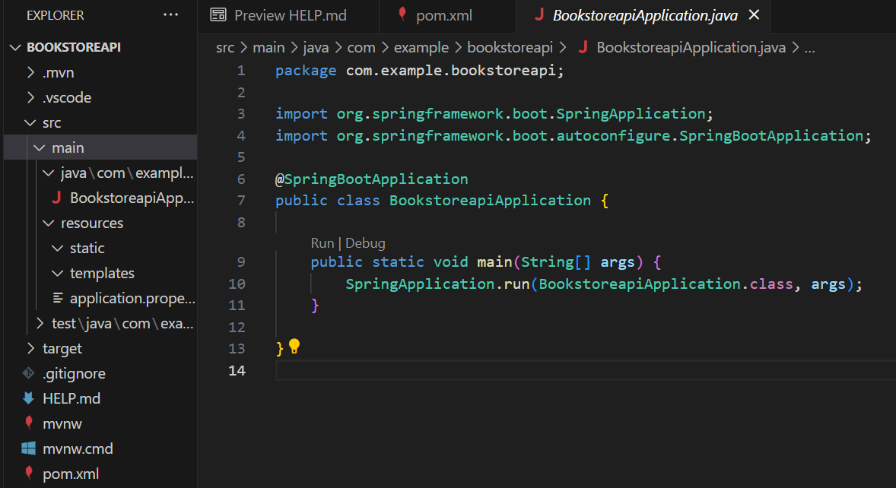

1. **What's New in Spring Boot 3:**
   * Explore and document the new features introduced in Spring Boot 3.

**ANS 3. Key Features and Updates**:

1. **Java 17+ Support**: Spring Boot 3 requires Java 17 or newer, offering new language features and enhanced performance.
2. **Spring Framework 6**: Upgraded to Spring Framework 6, bringing improvements like enhanced support for reactive programming and better integration with Java 21 features.
3. **Native Compilation**: Improved support for GraalVM native image compilation for faster startup times and reduced memory consumption.
4. **Dependency Upgrades**: Updated dependencies for major libraries and frameworks (e.g., Hibernate, Tomcat).
5. **Enhanced Observability**: Improved support for metrics and tracing with Micrometer and OpenTelemetry.
6. **Configuration Properties Binding**: Improved support for binding configuration properties to Java beans with better validation.
7. **Spring Data JDBC Improvements**: Simplified data access with Spring Data JDBC enhancements.
8. **New Spring Boot CLI Features**: Enhanced command-line interface with improved support for scripting and automation.

**Exercise 2: Online Bookstore - Creating Basic REST Controllers**

**Business Scenario:**

Implement RESTful endpoints to manage books.

**Instructions:**

1. **Create Book Controller:**
   * Define a **BookController** class with request mappings for /books.
2. **Handle HTTP Methods:**
   * Implement methods to handle **GET**, **POST**, **PUT**, and **DELETE** requests

BookController.java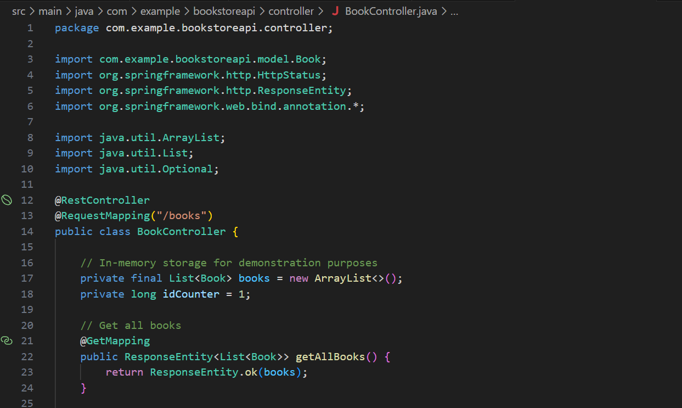 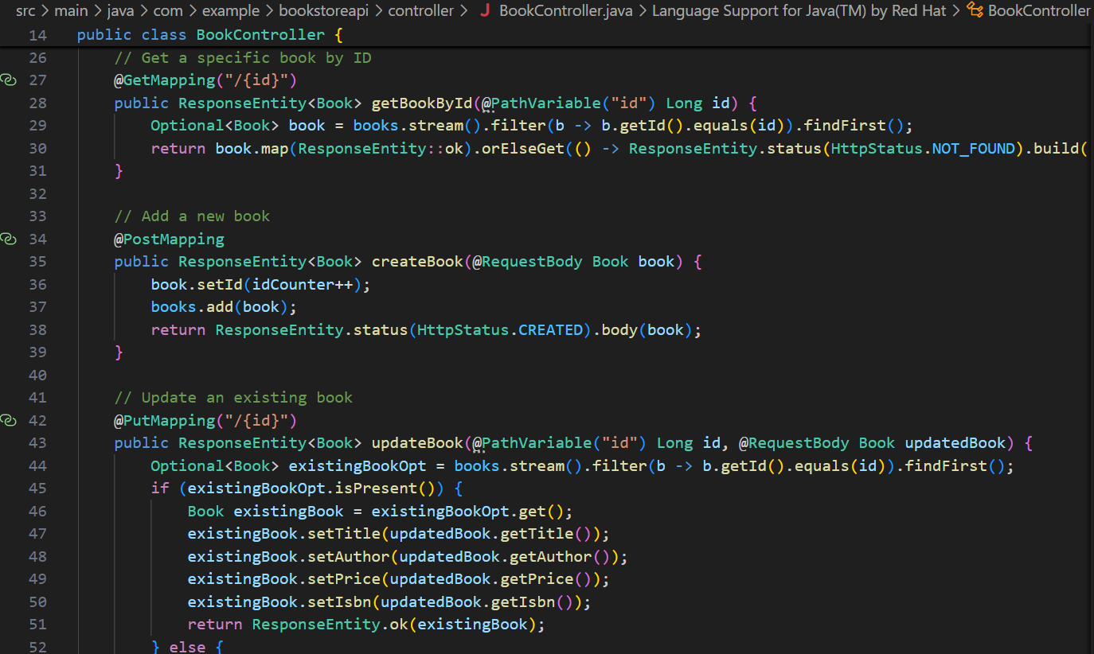 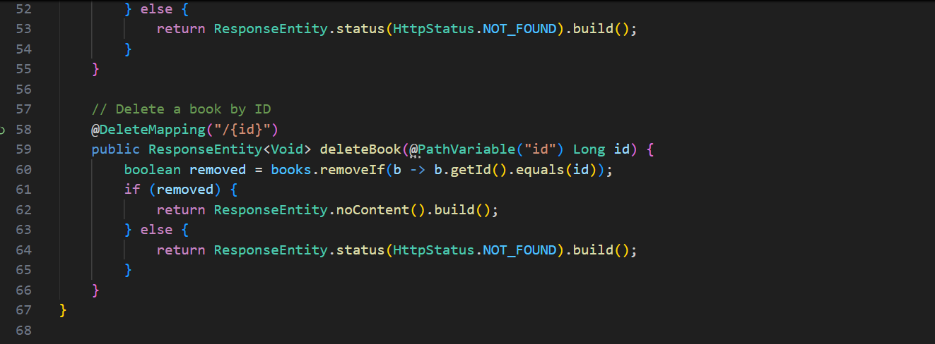

1. **Return JSON Responses:**
   * Ensure the controller returns JSON responses.
   * Define the Book entity with attributes like **id, title, author, price**, and **isbn**.

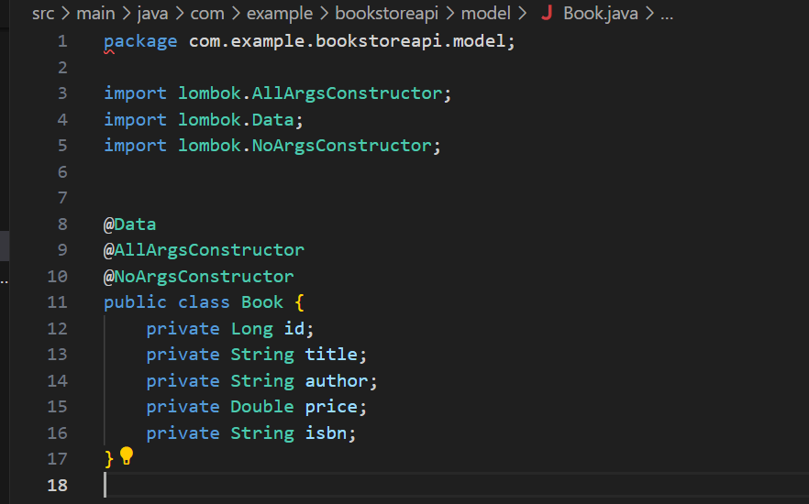

Book.java

**Exercise 3: Online Bookstore - Handling Path Variables and Query Parameters**

**Business Scenario:**

Enhance the book management endpoints to handle dynamic URLs and query parameters.

**Instructions:**

1. **Path Variables:**
   * Implement an endpoint to fetch a book by its ID using a path variable.

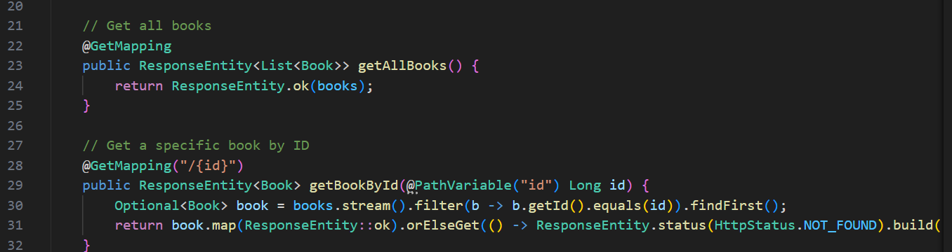

1. **Query Parameters:**
   * Implement an endpoint to filter books based on query parameters like title and author.

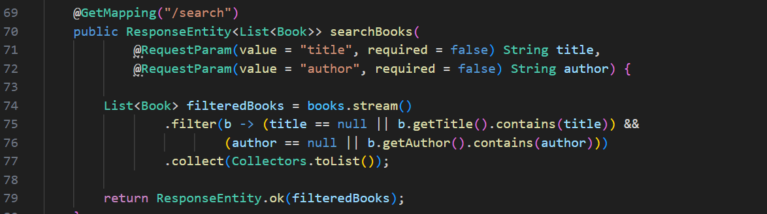

**Exercise 4: Online Bookstore - Processing Request Body and Form Data**

**Business Scenario:**

Create endpoints to accept and process JSON request bodies and form data for customer registrations.

**Instructions:**

1. **Request Body:**
   * Implement a POST endpoint to create a new customer by accepting a JSON request body.
2. **Form Data:**
   * Implement an endpoint to process form data for customer registrations.

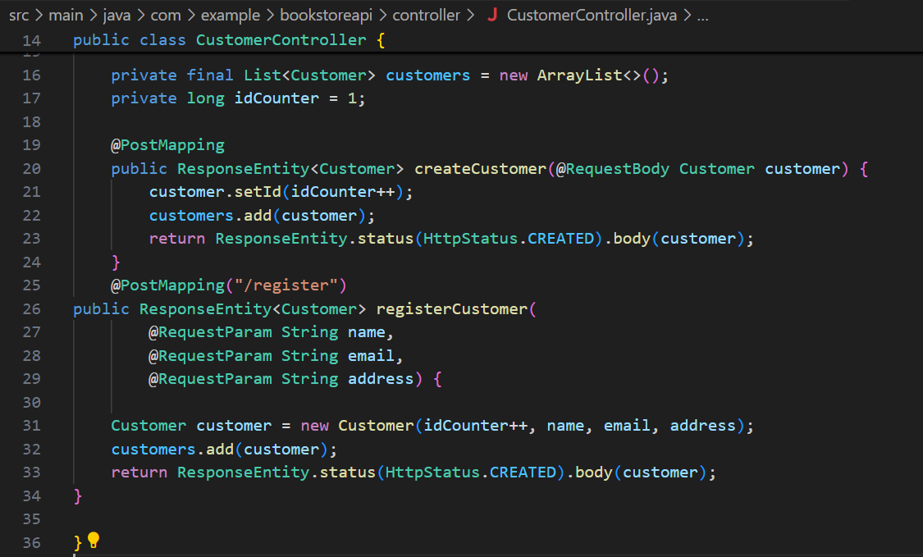

**Exercise 5: Online Bookstore - Customizing Response Status and Headers**

**Business Scenario:**

Customize the HTTP response status and headers for the book management endpoints.

**Instructions:**

1. **Response Status:**
   * Use **@ResponseStatus** to customize HTTP status codes for your endpoints.

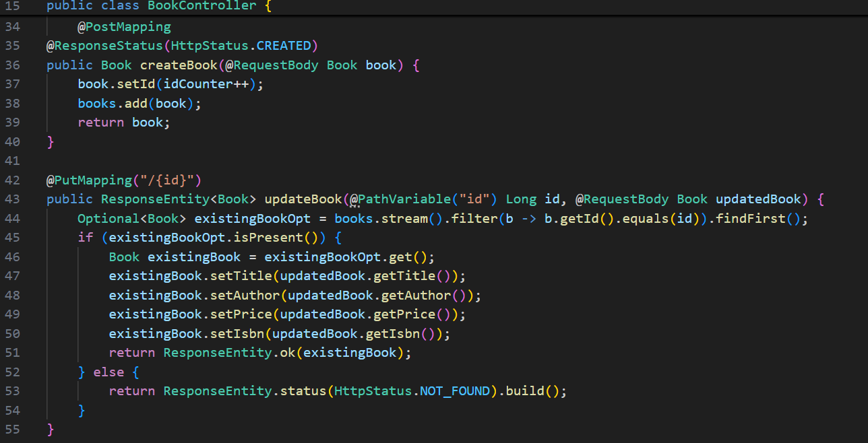

1. **Custom Headers:**
   * Add custom headers to the response using **ResponseEntity**.

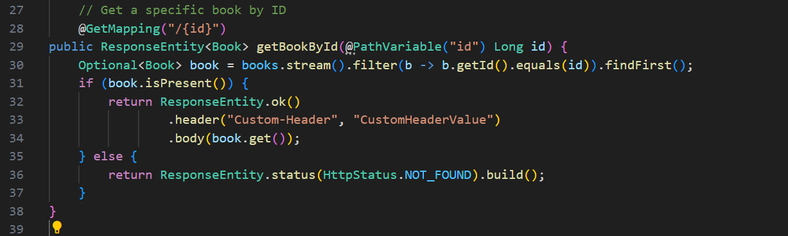

**Exercise 6: Online Bookstore - Exception Handling in REST Controllers**

**Business Scenario:**

Implement a global exception handling mechanism for the bookstore RESTful services.

**Instructions:**

1. **Global Exception Handler:**
   * Create a **GlobalExceptionHandler** class using **@ControllerAdvice**.
   * Define methods to handle various exceptions and return appropriate HTTP status codes.

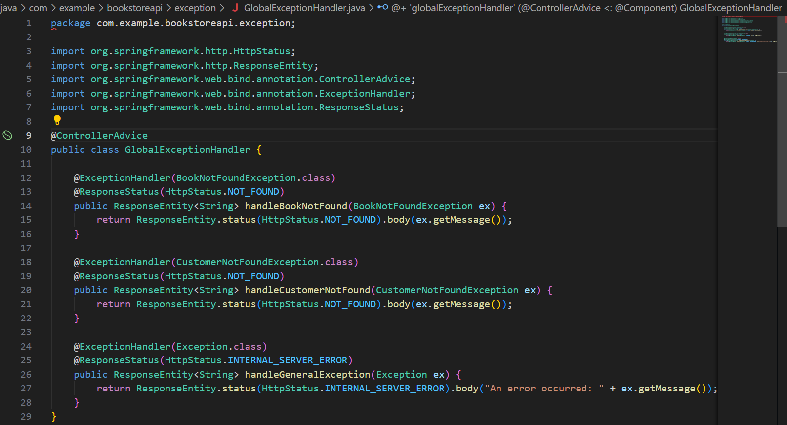

**GlobalExceptionHandler.java**

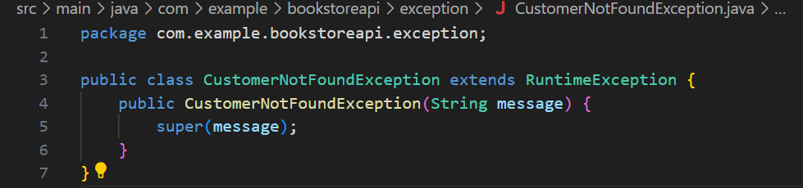

CustomerNotFoundException.java

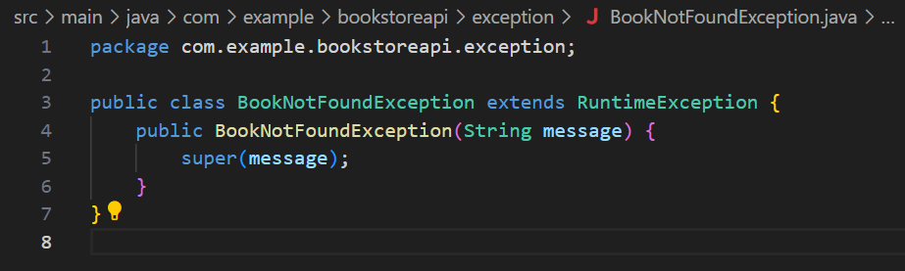

BookNotFoundException.java

**Exercise 7: Online Bookstore - Introduction to Data Transfer Objects (DTOs)**

**Business Scenario:**

Use DTOs to transfer data between the client and server for books and customers.

**Instructions:**

1. **Create DTOs:**
   * Define BookDTO and CustomerDTO classes.

BookDTO.java 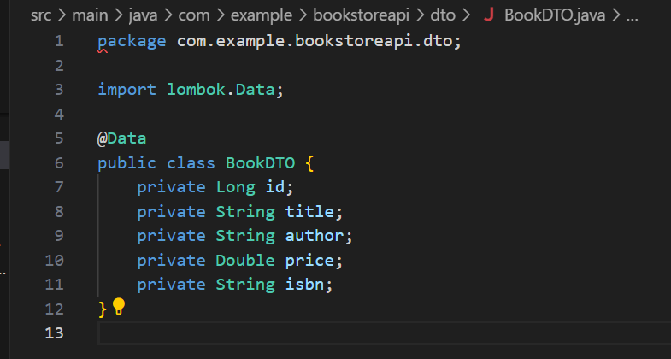

CustomerDTO.java

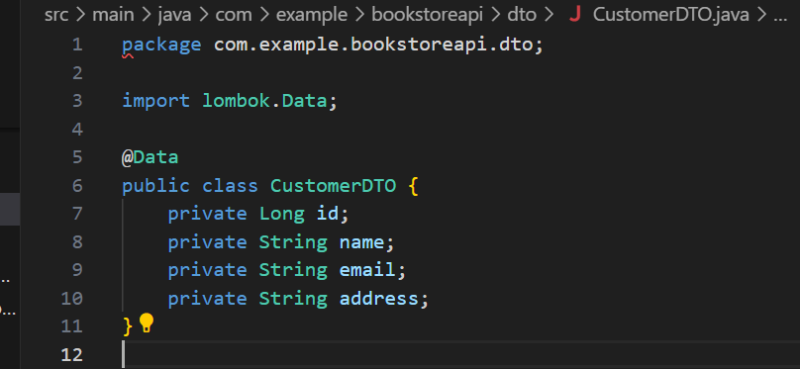

1. **Mapping Entities to DTOs:**
   * Use a library like **MapStruct** or **ModelMapper** to map entities to DTOs and vice versa.
2. **Custom Serialization/Deserialization:**
   * Customize JSON serialization and deserialization using Jackson annotations.

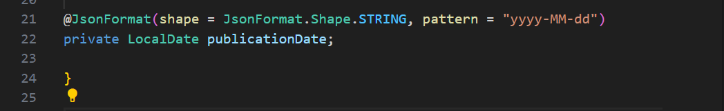

**Exercise 8: Online Bookstore - Implementing CRUD Operations**

**Business Scenario:**

Implement Create, Read, Update, and Delete operations for the Book and Customer entities.

**Instructions:**

1. **CRUD Endpoints:**
   * Implement endpoints for creating, reading, updating, and deleting books and customers.
2. **Validating Input Data:**
   * Use validation annotations like **@NotNull, @Size**, and **@Min** to validate input data.
3. **Optimistic Locking:**
   * Implement optimistic locking for concurrent updates using JPA versioning.

**Exercise 9: Online Bookstore - Understanding HATEOAS**

**Business Scenario:**

Enhance your REST API to follow HATEOAS principles for navigation through resources.

**Instructions:**

1. **Add Links to Resources:**
   * Use **Spring HATEOAS** to add links to resources in your API responses.
2. **Hypermedia-Driven APIs:**
   * Build and consume hypermedia-driven APIs.

**Exercise 10: Online Bookstore - Configuring Content Negotiation**

**Business Scenario:**

Support different media types (JSON, XML) for your bookstore's RESTful services.

**Instructions:**

1. **Content Negotiation:**
   * Configure Spring Boot to support content negotiation.
2. **Accept Header:**
   * Implement logic to produce and consume different media types based on the Accept header.

**Exercise 11: Online Bookstore - Integrating Spring Boot Actuator**

**Business Scenario:**

Monitor and manage your bookstore's RESTful services using Spring Boot Actuator.

**Instructions:**

1. **Add Actuator Dependency:**
   * Include the Spring Boot Actuator dependency in your project.
2. **Expose Actuator Endpoints:**
   * Enable and customize Actuator endpoints.
3. **Custom Metrics:**
   * Expose custom metrics for monitoring your application.

**Exercise 12: Online Bookstore - Securing RESTful Endpoints with Spring Security**

**Business Scenario:**

Secure your bookstore's RESTful endpoints using Spring Security with JWT-based authentication.

**Instructions:**

1. **Add Spring Security:**
   * Integrate Spring Security into your project.
2. **JWT Authentication:**
   * Implement JWT-based authentication and authorization.
3. **CORS Handling:**
   * Configure CORS to handle cross-origin requests.

**Exercise 13: Online Bookstore - Unit Testing REST Controllers**

**Business Scenario:**

Write unit tests for your bookstore's REST controllers using JUnit and Mockito.

**Instructions:**

1. **JUnit Setup:**
   * Set up JUnit and Mockito in your project.
2. **MockMvc:**
   * Use MockMvc to write unit tests for your REST controllers.
3. **Test Coverage:**
   * Ensure comprehensive test coverage and follow best practices for testing.

**Exercise 14: Online Bookstore - Integration Testing for REST Services**

**Business Scenario:**

Write integration tests for your bookstore's RESTful services.

**Instructions:**

1. **Spring Test:**
   * Set up Spring Test for integration testing.
2. **MockMvc Integration:**
   * Use MockMvc for end-to-end testing of your REST endpoints.
3. **Database Integration:**
   * Include database integration in your tests using an in-memory database like **H2**.

**Scenario 15: Online Bookstore - API Documentation with Swagger**

**Business Scenario:**

Document your bookstore's REST APIs using Swagger and Springdoc.

**Instructions:**

1. **Add Swagger Dependency:**
   * Include Swagger or Springdoc dependencies in your project.
2. **Document Endpoints:**
   * Annotate your REST controllers and methods to generate API documentation.
3. **API Documentation:**
   * Generate and review the API documentation using **Swagger UI** or **Springdoc UI**.